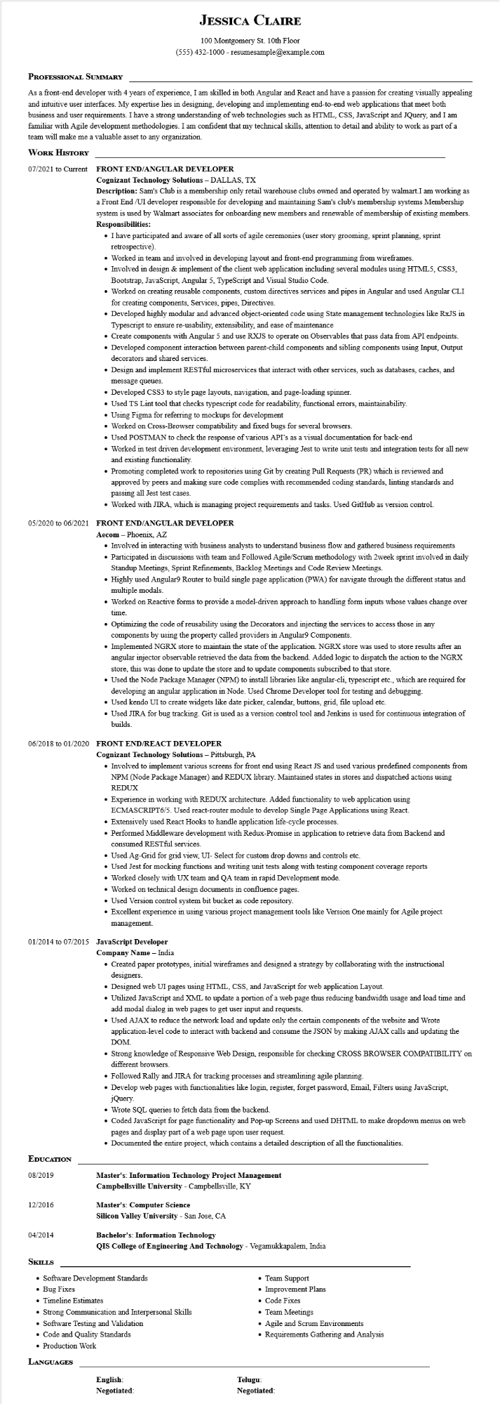
JESSICA CLAIRE
100 Montgomery St. 10th Floor (555) 432-1000 - resumesample@example.com
PROFESSIONAL SUMMARY
As a front-end developer with 4 years of experience, I am skilled in both Angular and React and have a passion for creating visually appealing and intuitive user interfaces. My expertise lies in designing, developing and implementing end-to-end web applications that meet both business and user requirements. I have a strong understanding of web technologies such as HTML, CSS, JavaScript and JQuery, and I am familiar with Agile development methodologies. I am confident that my technical skills, attention to detail and ability to work as part of a team will make me a valuable asset to any organization.
WORK HISTORY
07/2021 to Current FRONT END/ANGULAR DEVELOPER
Cognizant Technology Solutions - DALLAS, TX
Description: Sam's Club is a membership only retail warehouse clubs owned and operated by walmart.I am working as a Front End /UI developer responsible for developing and maintaining Sam's club's membership systems Membership system is used by Walmart associates for onboarding new members and renewable of membership of existing members. Responsibilities:
• I have participated and aware of all sorts of agile ceremonies (user story grooming, sprint planning, sprint retrospective).
• Worked in team and involved in developing layout and front-end programming from wireframes.
• Involved in design & implement of the client web application including several modules using HTML5, CSS3, Bootstrap, JavaScript, Angular 5, TypeScript and Visual Studio Code.
• Worked on creating reusable components, custom directives services and pipes in Angular and used Angular CLI for creating components, Services, pipes, Directives.
• Developed highly modular and advanced object-oriented code using State management technologies like RxJS in Typescript to ensure re-usability, extensibility, and ease of maintenance
• Create components with Angular 5 and use RXJS to operate on Observables that pass data from API endpoints.
• Developed component interaction between parent-child components and sibling components using Input, Output decorators and shared services.
• Design and implement RESTful microservices that interact with other services, such as databases, caches, and message queues.
• Developed CSS3 to style page layouts, navigation, and page-loading spinner.
• Used TS Lint tool that checks typescript code for readability, functional errors, maintainability.
• Using Figma for referring to mockups for development
• Worked on Cross-Browser compatibility and fixed bugs for several browsers.
• Used POSTMAN to check the response of various API's as a visual documentation for back-end
• Worked in test driven development environment, leveraging Jest to write unit tests and integration tests for all new and existing functionality.
• Promoting completed work to repositories using Git by creating Pull Requests (PR) which is reviewed and approved by peers and making sure code complies with recommended coding standards, linting standards and passing all Jest test cases.
• Worked with JIRA, which is managing project requirements and tasks. Used GitHub as version control.
05/2020 to 06/2021 FRONT END/ANGULAR DEVELOPER
Aecom - Phoenix, AZ
• Involved in interacting with business analysts to understand business flow and gathered business requirements
• Participated in discussions with team and Followed Agile/Scrum methodology with 2week sprint involved in daily Standup Meetings, Sprint Refinements, Backlog Meetings and Code Review Meetings.
• Highly used Angular9 Router to build single page application (PWA) for navigate through the different status and multiple modals.
• Worked on Reactive forms to provide a model-driven approach to handling form inputs whose values change over
time.
• Optimizing the code of reusability using the Decorators and injecting the services to access those in any components by using the property called providers in Angular9 Components.
• Implemented NGRX store to maintain the state of the application. NGRX store was used to store results after an angular injector observable retrieved the data from the backend. Added logic to dispatch the action to the NGRX store, this was done to update the store and to update components subscribed to that store.
• Used the Node Package Manager (NPM) to install libraries like angular-cli, typescript etc., which are required for developing an angular application in Node. Used Chrome Developer tool for testing and debugging.
• Used kendo UI to create widgets like date picker, calendar, buttons, grid, file upload etc.
• Used JIRA for bug tracking. Git is used as a version control tool and Jenkins is used for continuous integration of builds.
06/2018 to 01/2020 FRONT END/REACT DEVELOPER
Cognizant Technology Solutions - Pittsburgh, PA
• Involved to implement various screens for front end using React JS and used various predefined components from NPM (Node Package Manager) and REDUX library. Maintained states in stores and dispatched actions using REDUX
• Experience in working with REDUX architecture. Added functionality to web application using ECMASCRIPT6/5. Used react-router module to develop Single Page Applications using React.
• Extensively used React Hooks to handle application life-cycle processes.
• Performed Middleware development with Redux-Promise in application to retrieve data from Backend and consumed RESTful services.
• Used Ag-Grid for grid view, UI- Select for custom drop downs and controls etc.
• Used Jest for mocking functions and writing unit tests along with testing component coverage reports
• Worked closely with UX team and QA team in rapid Development mode.
• Worked on technical design documents in confluence pages.
• Used Version control system bit bucket as code repository.
• Excellent experience in using various project management tools like Version One mainly for Agile project management.
01/2014 to 07/2015 JavaScript Developer
Company Name - India
• Created paper prototypes, initial wireframes and designed a strategy by collaborating with the instructional designers.
• Designed web UI pages using HTML, CSS, and JavaScript for web application Layout.
• Utilized JavaScript and XML to update a portion of a web page thus reducing bandwidth usage and load time and add modal dialog in web pages to get user input and requests.
• Used AJAX to reduce the network load and update only the certain components of the website and Wrote application-level code to interact with backend and consume the JSON by making AJAX calls and updating the
DOM.
• Strong knowledge of Responsive Web Design, responsible for checking CROSS BROWSER COMPATIBILITY on different browsers.
• Followed Rally and JIRA for tracking processes and streamlining agile planning.
• Develop web pages with functionalities like login, register, forget password, Email, Filters using JavaScript, jQuery.
• Wrote SQL queries to fetch data from the backend.
• Coded JavaScript for page functionality and Pop-up Screens and used DHTML to make dropdown menus on web pages and display part of a web page upon user request.
• Documented the entire project, which contains a detailed description of all the functionalities.
EDUCATION
08/2019
Master's: Information Technology Project Management
Campbellsville University - Campbellsville, KY
12/2016
Master's: Computer Science
Silicon Valley University - San Jose, CA
04/2014
SKILLS
Bachelor's: Information Technology
QIS College of Engineering And Technology - Vegamukkapalem, India
• Software Development Standards
• Bug Fixes
• Timeline Estimates
• Strong Communication and Interpersonal Skills
• Software Testing and Validation
• Code and Quality Standards
• Production Work
LANGUAGES
• Team Support
Improvement Plans
• Code Fixes
• Team Meetings
• Agile and Scrum Environments
• Requirements Gathering and Analysis
English: Negotiated:
Telugu: Negotiated:

